Working with Spring Boot Web, Data and JPA

Student Workbook
Version 1.2
Table of Contents
Module 1 v
Spring Boot Web v
Section 1–1 Spring Boot Web Overview vi
Spring Boot Web Overview vii
Creating a project with Spring Boot Web viii
Adding the “web” dependency ix
Inspecting the project x
Running the project xi
Exercises xii
Section 1–2 Spring MVC xiii
Spring MVC 1-14
Creating a Model 1-16
Exercises 1-17
Creating a Resource Controller 1-18
Running the application 1-19
Working with query parameters 1-20
Working with path parameters 1-21
Working with a request body 1-22
Working with a request body with a custom object 1-24
Sending a request body with a custom object 1-25
Exercises 1-26
Working with views 1-27
Controller vs RestController 1-28
Using Thymeleaf 1-29
Conditions in Thymeleaf 1-31
Loops in Thymeleaf 1-32
Loops in Thymeleaf cont'd 1-33
Working with objects in Thymeleaf 1-34
Working with objects in Thymeleaf cont'd 1-35
Add forms in Thymeleaf 1-36
Add forms in Thymeleaf cont'd 1-37
Exercises 1-38
Module 2 Spring Data JPA 2-39
Section 2–1 Understanding REST services 2-40
REST API 2-41
How REST APIs are built up 2-42
Section 2–2 Understanding ORMs 2-43
Object Relational Mapping (ORM) 2-44
JPA and Hibernate 2-45
Section 2–3 Getting started with Spring Boot Data JPA 2-46
Configuring the application 2-47
Creating entities 2-48
Creating entities cont'd 2-49
Creating entities cont'd 2-50
Creating a repository 2-51
Creating a service 2-52
Creating a REST controller 2-53
Calling the REST API 2-54
Exercises 2-55
Exercises cont’d 2-57
Section 2–4 More complex data with Spring Boot Data JPA 2-58
Working with different relationships 2-59

Spring Boot Web

Spring Boot Web Overview

Spring Boot Web Overview

Spring Boot Web is a starting point for creating web applications

Added by adding the following dependency to the pom.xml:
<dependency>
<groupId>org.springframework.boot</groupId>
<artifactId>spring-boot-starter-web</artifactId>
<version>2.2.2.RELEASE</version>
</dependency>

By adding the dependency to the pom.xml, the following necessities for web development are added and autoconfigured:

Dispatcher Servlet

Embedded Servlet container (embedded Tomcat server)

Error Page

Web JARS for static dependency management

We can also generate our project via start.spring.io including the dependencies with the initializer

Creating a project with Spring Boot Web

Go https://start.spring.io/

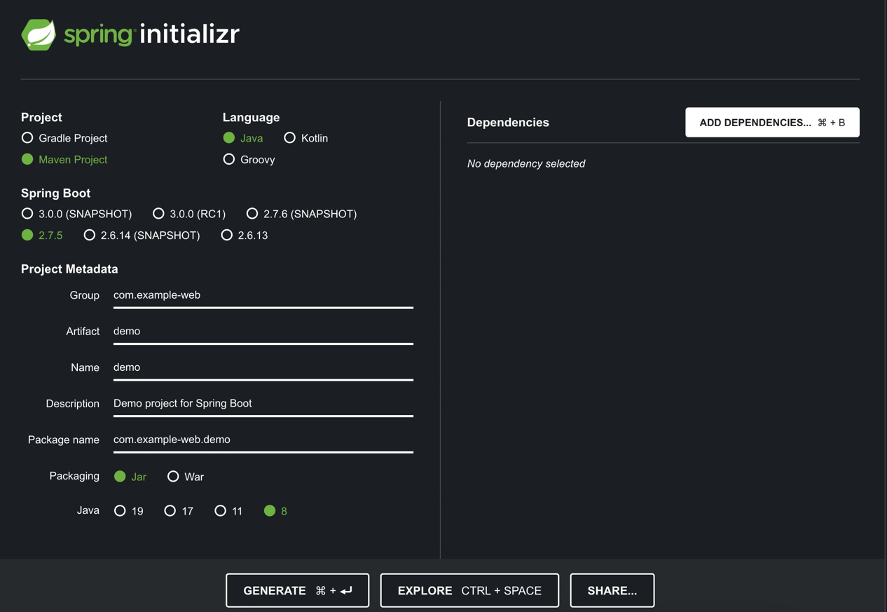

Click on “Add dependencies”

Adding the “web” dependency

Select the Spring Web dependency - note that Spring MVC is not a separate dependency, but rather it comes with Spring Web

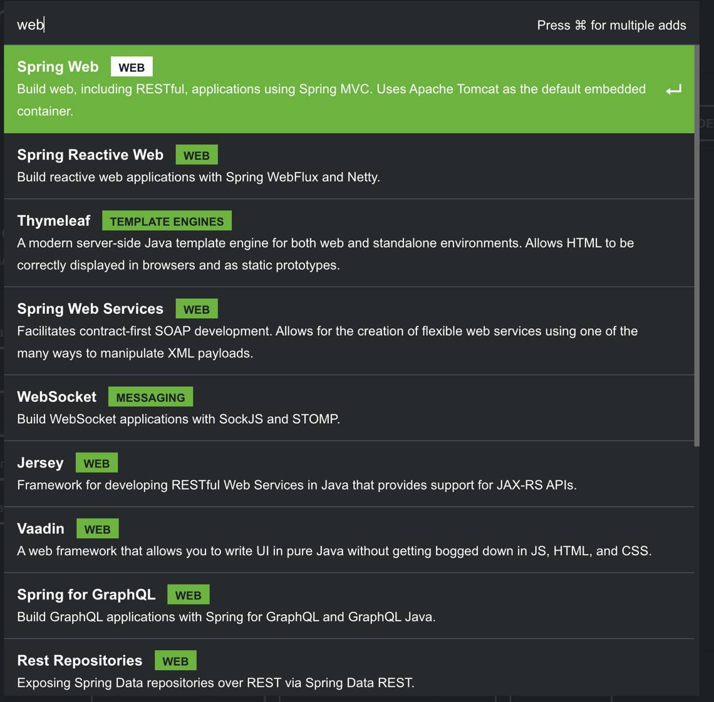

Click on “Generate”

Unzip the project and import in Eclipse

Inspecting the project

There are a lot of dependencies added

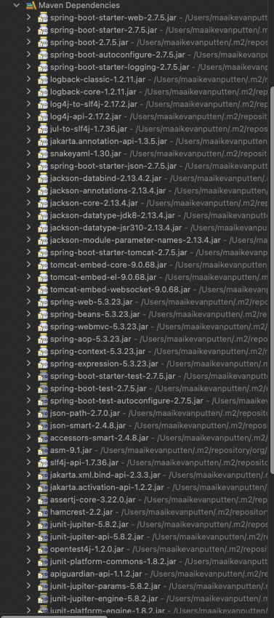

Running the project

When we run the project, the application keeps running and doesn’t terminate automatically

We can also see that Tomcat has started

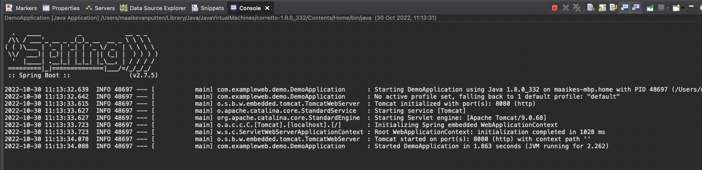

The web application is running until we end it

Exercises
- Go to start.spring.io
- Create a project for the renewed HR app
- Add the web dependency
- Generate the project
- Import it in IntelliJ
- Run the project

Spring MVC

Spring MVC

Popular spring solution for building a web application with the Spring Framework

Follows the Model-View-Controller design pattern

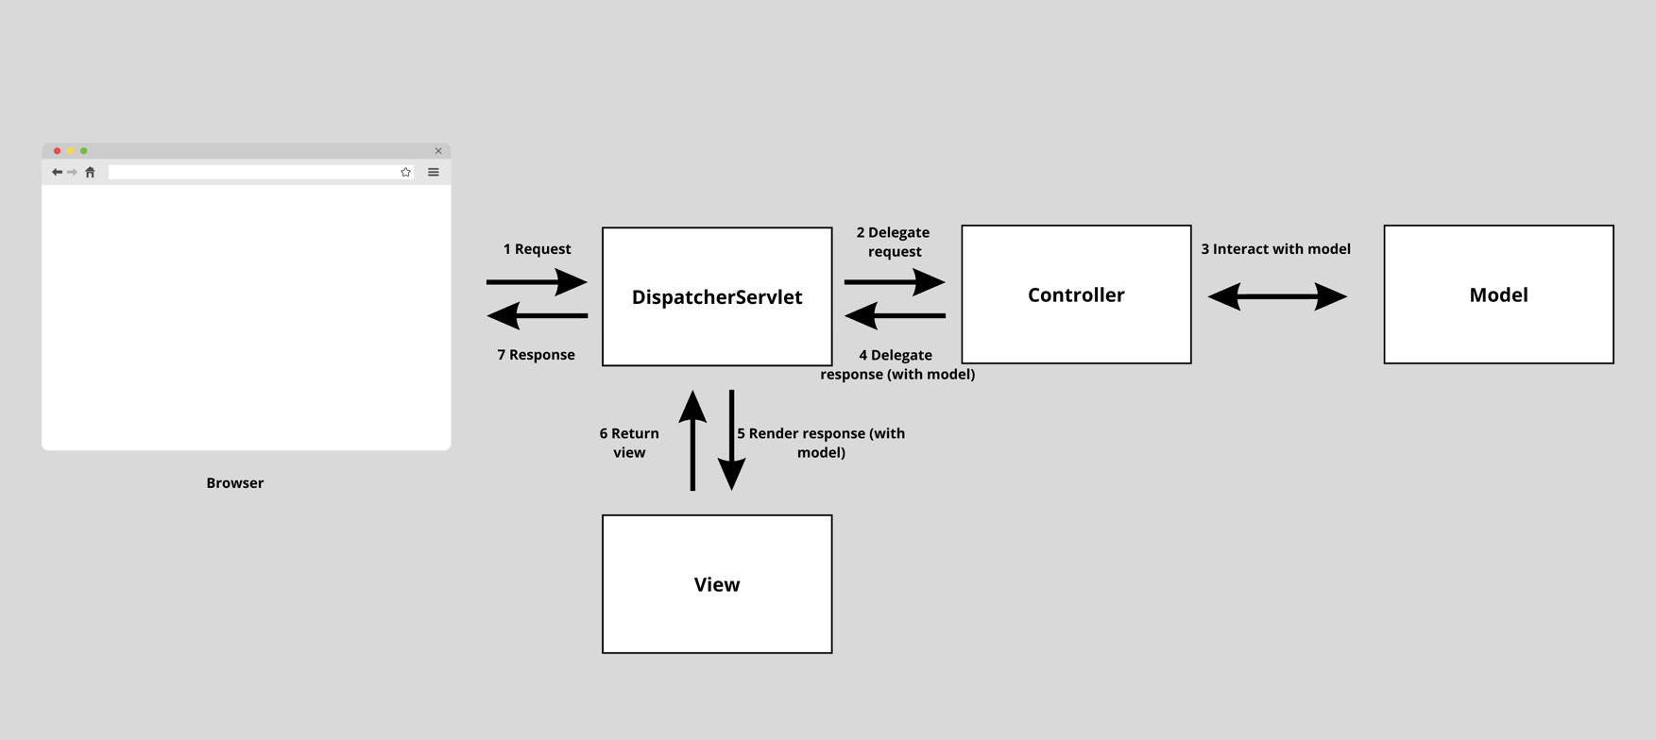
Uses IoC and DI as we have seen before to accomplish all this

Model: holds the data of the application

View: what the end user sees (achieved by a template engine: HTML with variables)

Controller: business logic using the data (often the controller layer consists of multiple layers such as controller, service, repository)

Creating a Model
package com.intuit.example.models;

public class Greeting {

private final long id;
private final String content;

public Greeting(long id, String content) {
this.id = id;
this.content = content;
}

public long getId() {
return id;
}

public String getContent() {
return content;
}
}

Exercises
EXERCISE 1 (easy - just copy above)
- Create a package example, with a sub package models
- Create a new class Greeting
- Copy the Greeting example line by line and make sure that you understand what is going on.

EXERCISE 2 (normal)
We’re going to add the model for Employee.
- Use the same package models
- In this package, add the class Employee
- Give the model fields for:
- Id
- Name
- Job
- Salary
- Date of birth

Creating a Resource Controller

We can create a Greeting Controller, as part of MVC (Model View Controller)

A Controller in Spring Web is nothing more than a class with special annotations that contains URL endpoints

Using annotations, we can map what URL will get sent over to your application. Some examples:

@GetMapping

@PostMapping

@PutMapping

@DeleteMapping

package com.intuit.example.controller;

import java.util.concurrent.atomic.AtomicLong;

import org.springframework.web.bind.annotation.GetMapping;
import org.springframework.web.bind.annotation.RequestParam;
import org.springframework.web.bind.annotation.RestController;

@RestController
public class GreetingController {

private final AtomicLong counter = new AtomicLong();

@GetMapping("/greeting")
public Greeting greeting(@RequestParam(value = "name", defaultValue = "World") String name) {
return new Greeting(counter.incrementAndGet(), String.format("Hello, %s!", name));
}
}

Running the application

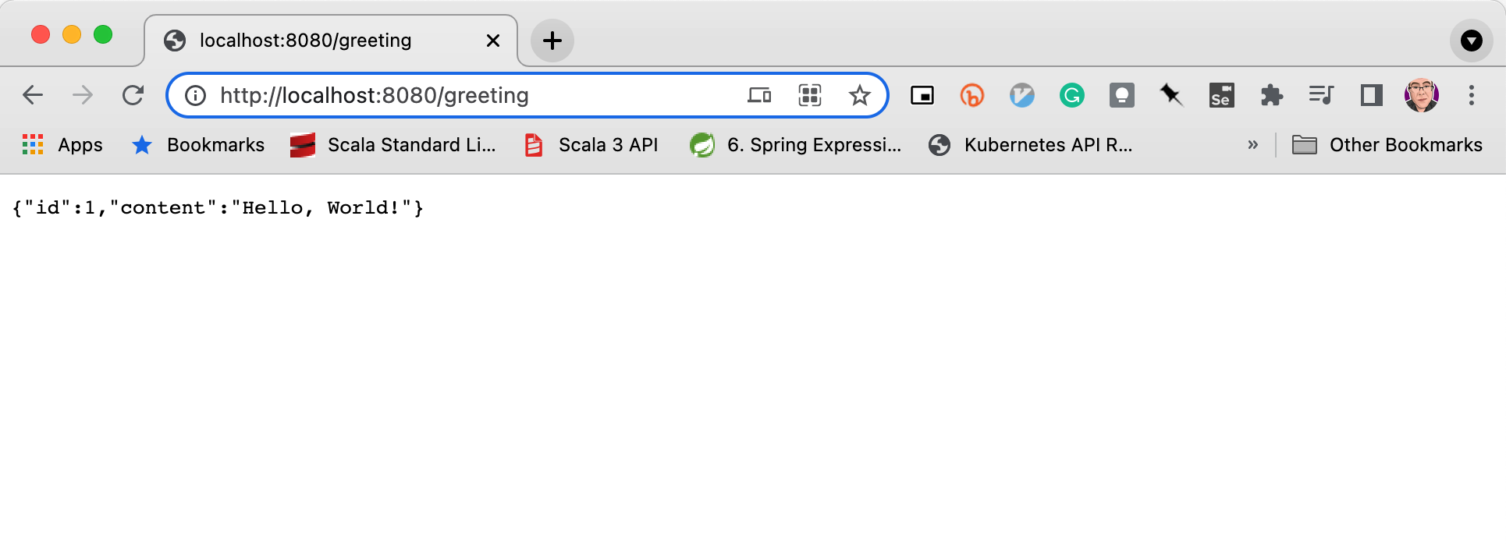

Often, we’d like to send input to the endpoints. There are three ways to do that:

Query parameters

Path parameters

Request body (common for post)

Working with query parameters

We can send input for the endpoints using query parameters. An example of a URL with a query parameter looks like this: http://localhost:8080/hi?name=all

We can tell the endpoint to look for the input parameters of the method in the URL query parameter list with the @RequestParam annotation
Example
@GetMapping("/hi")
public String sayHiQueryParam(@RequestParam String name) {
return "Hi " + name;
}

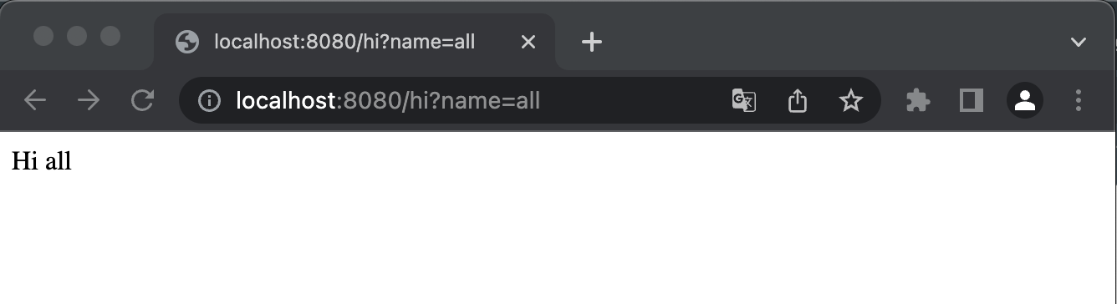

Working with path parameters

We can send input for the endpoints using path parameters. An example of a URL with a path parameter looks like this: http://localhost:8080/hi/maria

We actually cannot tell by the URL that it accepts a path parameter, it could also be the literal path.

But we can tell the endpoint to look for the input parameters of the method in the path by adding {nameVariable} to the mapping.
Example
@GetMapping("/hi/{name}")
public String sayHiPathParam(@PathVariable String name) {
return "Hi " + name;
}

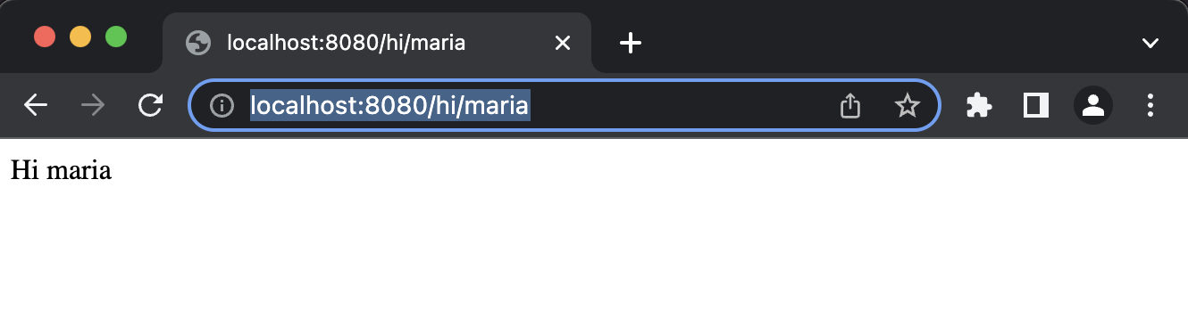

Working with a request body

We can send input for the endpoints using the request body. An example of a URL with a path parameter looks like this: http://localhost:8080/hi2

We actually cannot tell by the URL that it accepts a request body and we need a special program to send the body along.

We can tell the endpoint to look for the input parameters of the method in the request body by adding @RequestBody before the parameter in the parameter list.

These request bodies can also be (custom) objects.
Example
@GetMapping("/hi2")
public String sayHiRestBody(@RequestBody String name) {
return "Hi " + name;
}

The body:
Varoon

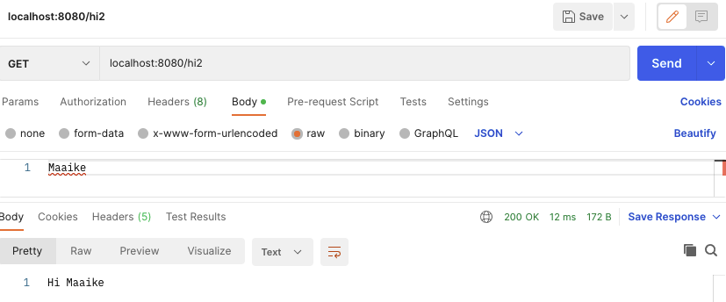

Working with a request body with a custom object

We can also work with custom objects and a request body
Example

Here is a Person class:

public class Person {
private String name;

public Person(String name) {
super();
this.name = name;
}

public Person() {}

public String getName() {
return name;
}

public void setName(String name) {
this.name = name;
}
}

And here is an endpoint accepting a request body with type person:

@GetMapping("/hiPerson")
public String sayHiPersonRestBody(@RequestBody Person p) {
return "Hi " + p.getName();
}

Sending a request body with a custom object

We can send the request by adding the JSON that represents a Person object - use the JSON option in Postman

This is what the body will look like:
{ "name": "Varoon" }

And here’s the full request:

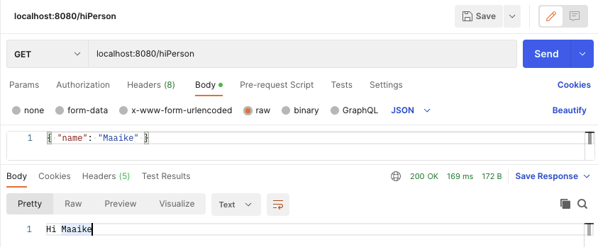

Exercises
EXERCISE 1 (easy, optional)
- Copy and inspect the example from the previous pages in the example package

EXERCISE 2
We’re going to create a controller for our Employee class.
- Add a package controllers
- Add the class EmployeeController to this package
- Give the class endpoint methods for:
- Adding a new employee, endpoint “employee”
- Getting all employees, endpoint “employees”
- Getting one employee by id, endpoint for example “employee/2”
- Getting one employee by name, endpoint for example “employee?name=bart”
- Updating an employee, endpoint for example “employee”
- Deleting an employee, endpoint for example “employee/2”
- These methods can be implemented with the use of a static collection or reading from a file.
- Call the endpoints from Fiddler or Postman

Working with views

We can create views for our application

Static view

View that is always the same, not dynamically loaded

No variables or relation to the data in the models

Can be returned by the controller

Dynamic view / template

View that contains variables

Data for the view comes from the controller

Controller returns the view

Multiple “template engines” are available, we’ll be working with thymeleaf

We need to add the following dependency to our pom.xml
<dependency>
<groupId>org.springframework.boot</groupId>
<artifactId>spring-boot-starter-thymeleaf</artifactId>
</dependency>

Controller vs RestController

When we want our controller to return views, we should not annotate our class with @RestController (for API’s), but with @Controller

The @Controller tries to return a view by default, the @RestController returns JSON

The @RestController is actually nothing more than a combination of @Controller and @ResponseBody

When we need to return a view, we use @Controller
Example
import org.springframework.stereotype.Controller;
import org.springframework.ui.Model;
import org.springframework.web.bind.annotation.GetMapping;
import org.springframework.web.bind.annotation.RequestParam;

@Controller
public class SomeController {
@GetMapping("hi")
public String list(Model model, @RequestParam String name) {
model.addAttribute("name", name);
return "example"; // needs a view with name example
}

}

Using Thymeleaf

Thymeleaf is a template engine

It allows us to type HTML with variables, loops and conditions

Spring expects the templates to exist in the following location: src/main/resources/templates

The name of the file should match what is returned from the controller (we called it example earlier)

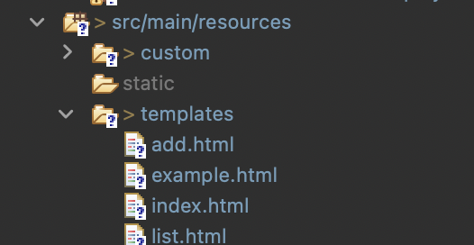

Thymeleaf variables are written between ${variableName}

The HTML element that uses thymeleaf contains “th”
Example
<!DOCTYPE html>
<html lang="en" xmlns:th="http://www.thymeleaf.org">
<head>
<meta charset="UTF-8">
<title>Hi there</title>
</head>
<body>
<p th:text="'Hi ' + ${name}"></p>
</body>
</html>

Conditions in Thymeleaf

Thymeleaf can work with conditions as well.

This can be done with th:if and th:unless

Th:if, the HTML element is shown when the condition is true

Th:unless, the HTML element is NOT shown when the condition is true

Th:if and th:text can be combined

Example
<!DOCTYPE html>
<html lang="en" xmlns:th="http://www.thymeleaf.org">
<head>
<meta charset="UTF-8">
<title>Hi there</title>
</head>
<body>
<p th:if="${name} == 'varoon'">Ah Varoon, I know him.</p>
<p th:unless="${name} == 'varoon'" th:text="'Ah, ' + ${name} + ', I don\'t know that person.'"></p>
</body>
</html>

Loops in Thymeleaf

Arrays and collections can be used in a loop

This is done with th:each

The block with the th:each in it, is repeated for every element in the loop

The controller must send a list to the view in order for this to be possible

Example

@Controller
public class SomeController {
@GetMapping("hi")
public String list(Model model, @RequestParam String name, @RequestParam String[] nameList) {
model.addAttribute("name", name);
model.addAttribute("names", nameList);
return "example";
}

}

Loops in Thymeleaf cont'd

The template can use the name of the variable as a list in the th:each
Example
<!DOCTYPE html>
<html lang="en" xmlns:th="http://www.thymeleaf.org">
<head>
<meta charset="UTF-8">
<title>Hi there</title>
</head>
<body>
<p th:text="'Hi ' + ${name}"></p>
<p th:if="${name} == 'Varoon'">Ah Varoon, I know him.</p>
<p th:unless="${name} == 'Varoon'"
th:text="'Ah, ' + ${name} + ', I don\'t know that person.'"></p>

<ul>
<li th:each="n: ${names}" th:text="${n}"></li>
</ul>
</body>
</html>

It can be called like this: http://localhost:8080/hi?name=maria&nameList=bert,ernie 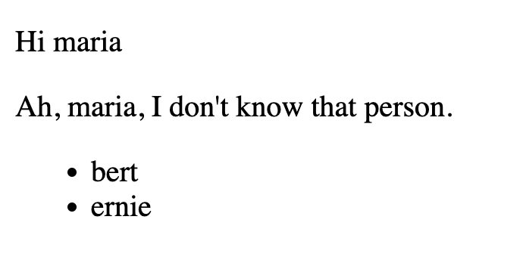

Working with objects in Thymeleaf

We can also work with objects and their properties in Thymeleaf templates

The controller should then return the object or list of objects
Example
@Controller
public class PersonController {
@GetMapping("person")
public String list(Model model, @RequestParam String name, @RequestParam int age) {
Person person = new Person(name, age);
Person person2 = new Person("Maaike", 31);
List<Person> persons = new ArrayList<>();
persons.add(person);
persons.add(person2);

model.addAttribute("person", person);
model.addAttribute("persons", persons);
return "person";
}
}

This example has a Person model with a private String name and a private int age (and getters and setters and a constructor)

Working with objects in Thymeleaf cont'd

In the template, we can use the object with this syntax: ${object.property}
Example
<!DOCTYPE html>

<html xmlns:th="http://www.thymeleaf.org">
<head>
<title>This is the title</title>
</head>
<body>
<p th:text="${person.name}"></p>
<p th:text="${person.age}"></p>
<hr>
<div th:each="p: ${persons}">
<p th:text="${p.name}"></p>
<p th:text="${p.age}"></p>
<p>----------</p>
</div>
</body>
</html>

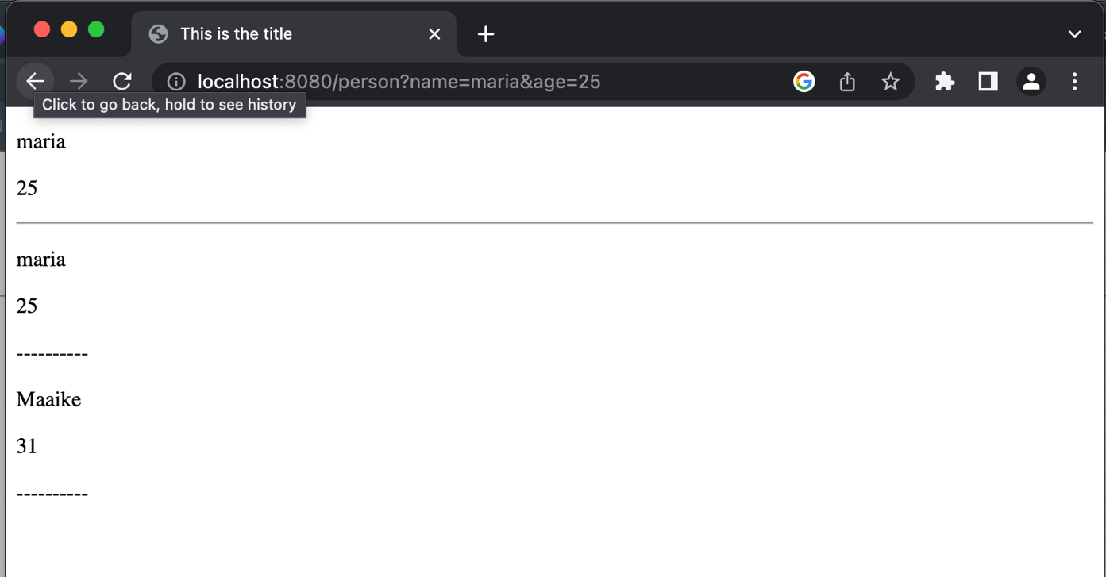

Add forms in Thymeleaf

We can also make forms for adding objects with the use of Thymeleaf

We use the th:action, th:object and th:field for this
Example
<!DOCTYPE HTML>
<html xmlns:th="https://www.thymeleaf.org">
<head>
<title>Person form</title>
<meta http-equiv="Content-Type" content="text/html; charset=UTF-8" />
</head>
<body>
<h1>Add person</h1>
<form action="#" th:action="@{/person}" th:object="${person}" method="post">
<p>Name: <input type="text" th:field="*{name}" /></p>
<p>Age: <input type="number" min=0 th:field="*{age}" /></p>
<p><input type="submit" value="Submit" /> <input type="reset" value="Reset" /></p>
</form>
</body>
</html>

Add forms in Thymeleaf cont'd

This needs to be picked up by the controller

In this case we have an html file called addPerson.html

These are the endpoints in the controller class

@PostMapping("person")
public String add(Model model, @ModelAttribute Person person) {
persons.add(person);
model.addAttribute("person", person);
model.addAttribute("persons", persons);
return "person";
}

@GetMapping("addperson")
public String list(Model model) {
model.addAttribute("person", new Person());
return "addPerson";
}

Exercises
EXERCISE 1 (easy, optional)
- Copy and inspect the example from the previous pages in the example package

EXERCISE 2
We are going to write another controller for our HR app. This controller is going to be returning views.
- Create the following views:
- Show all the employees in a table. (BONUS: include link to a page that shows details of one employee and a button for deleting the employee)
- Add an employee
- BONUS: Show employee details
- Create a controller with the following endpoints:
- Get all the employees (that returns the view under a)
- Add an employee
- BONUS: Get a specific employee (that matches the bonus link of a)
- BONUS: Delete an employee

Spring Data JPA

Understanding REST services

REST API

REST stands for Representational State Transfer

REST follows 4 principles:

1. Resource identification through URI, for example: <host>:<port>/application/persons

2. Uniform interface. Manipulation of resources through CRUD operations.

3. Self-descriptive messages. Resources are decoupled from their representations so the content can be accessed in more than one format (e.g. plain text, HTML, XML, JSON). Metadata in the message is used to do authentication, detect errors, caching, access control, etc.

4. Stateful interactions through hyperlinks. Every interaction with a resource is stateless. Stateful interactions can be done through URI manipulation, cookies, or hidden form fields.

How REST APIs are built up

Endpoints: methods in the controller that are mapped to a certain URI

Service layer: the methods in the controller typically point to a different class that contains the business logic, instead of having all of it in the controller (this is what we have seen so far). Separating this makes the application easier to maintain and the service methods are reusable.

Repository layer: whenever the service needs to interact with the data source, this is done via the repository layer. The repositories are classes that have the logic in them to access the data sources.

The controller typically has the services it needs available via dependency injection.

The service typically has the repositories it needs available via dependency injection.

We use the @RestController annotation for our controller when we write REST APIs.

Understanding ORMs

Object Relational Mapping (ORM)

When using JDBC, you’re getting a ResultSet back

In order to create an object from a ResultSet, we’d had to loop through the ResultSet to initialize the object
Example
public List<Country> getAllCountries() {
List<Country> countries = new ArrayList<>();
try(Connection conn = ds.getConnection();
PreparedStatement ps = conn.prepareStatement("SELECT * FROM country;");
ResultSet rs = ps.executeQuery()) {
while(rs.next()) {
Country c = new Country();
c.setId(rs.getInt("country_id"));
c.setCountry(rs.getString("country"));
c.setLastUpdate(new Timestamp(rs.getDate("last_update").getTime()).toLocalDateTime());
countries.add(c);
}

} catch (SQLException e) {
// TODO Auto-generated catch block
e.printStackTrace();
}
return countries;
}

ORM solutions do that part for you: instead of giving rows with results, they translate these (database) rows into (Java) objects

JPA and Hibernate

Java Persistence API (JPA) is the specification for data access, management, and persistence between the Java object and the relational database

JPA is defined in the javax.persistence package

JPA is merely a specification, it needs implementing

Hibernate is an example of an implementation of the JPA, it’s an ORM tool

Hibernate is defined in the org.hibernate package

Let’s initially see how to use it in combination with Spring Boot to persist and access data, then we can get more complex

Hibernate documentation can be found here: https://hibernate.org/orm/documentation

Getting started with Spring Boot Data JPA

Configuring the application

We are going to add the following dependencies to our pom.xml:

<dependency>
<groupId>org.springframework.boot</groupId>
<artifactId>spring-boot-starter-data-jpa</artifactId>
</dependency>

<dependency>
<groupId>com.h2database</groupId>
<artifactId>h2</artifactId>
<scope>runtime</scope>
</dependency>

Spring boot starter Data JPA uses Hibernate as the default implementation (this is the ORM we will be using)
- JPA == Java persistence API, gives a spec for ORM’s and also other Spring boot behavior
- Hibernate == ORM (maps the database to the application)
- H2 == actual RELATIONAL, in-memory, database we were using (we would NOT be able to use a NoSQL database with an ORM b/c that would not make sense given it’s a relational mapping)

H2 is an in-memory database, which means that the data will be gone upon restart (this is the actual “database” we will be using)

This is great for testing and getting started

We need to add the following lines to our application.properties to see the database management system
spring.h2.console.enabled=true
spring.datasource.url=jdbc:h2:mem:testdb
spring.datasource.driverClassName=org.h2.Driver
spring.datasource.username=sa
spring.datasource.password=
spring.jpa.database-platform=org.hibernate.dialect.H2Dialect

Creating entities

Entities are POJOs that represent data and can be persisted to the database

A table for the entity will be created automatically

We can turn our models into entities by adding an annotation to the class and the id property (IntelliJ might use different libraries for import, that should be fine - it might suggest jakarta)

import jakarta.persistence.Entity;
import jakarta.persistence.GeneratedValue;
import jakarta.persistence.Id;

// this annotation tells JPA/Hibernate to create a table
// called Person and rows of that table will be individual
// objects of Person…Id is the primary key for the table
@Entity
public class Person {
@Id
@GeneratedValue
private String name;

private Long id;

public Person(String name) {
super();
this.name = name;
}

public Person() {}

public String getName() {
return name;
}
public void setName(String name) {
this.name = name;
}
public Long getId() {
return id;
}
public void setId(Long id) {
this.id = id;
}

}

Creating entities cont'd

In order to test our entity, we can create an import.sql file in our resources folder
Example
insert into person values(1, 'Pradeepa');
insert into person values(2, 'Courtney');
insert into person values(3, 'Emin');

Upon application start, this file will be executed

However, you will likely see an error in the IntelliJ output - try to troubleshoot it on your own!

We can then go to http://localhost:8080/h2-console to see the result
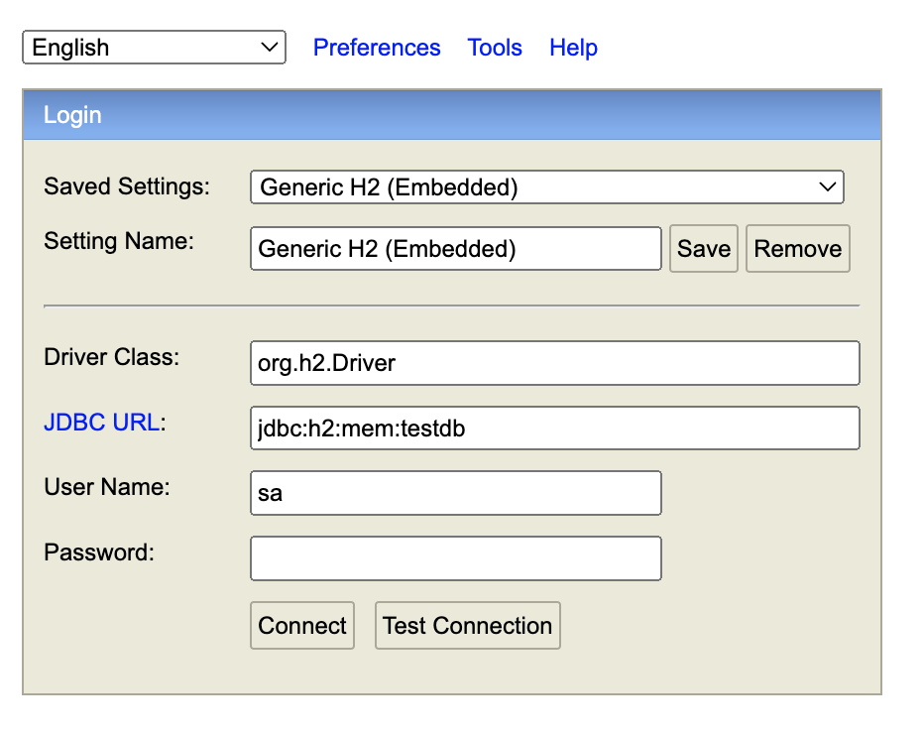

Creating entities cont'd

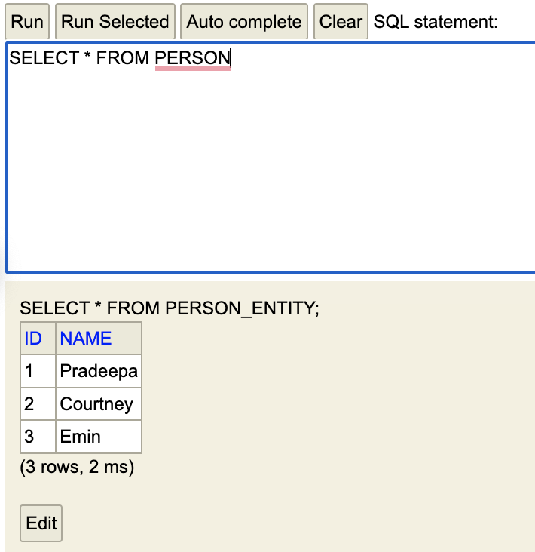

Let’s see how we can add objects to our database with Java

Creating a repository

We need a repository class to encapsulate the logic to access the data source

With Spring Boot we can save a lot of boilerplate code by using their built-in repository object
- Go ahead and create this in a separate package for repository as well
Example
//JPA will provide a default implementation of this for us
import org.springframework.data.repository.CrudRepository;

public interface PersonRepository extends CrudRepository<Person, Long> {

}

This will create the data layer for accessing, managing, and persisting, in this case Person, objects

Repositories are typically called from the service layer

Here’s a diagram explaining the layers:

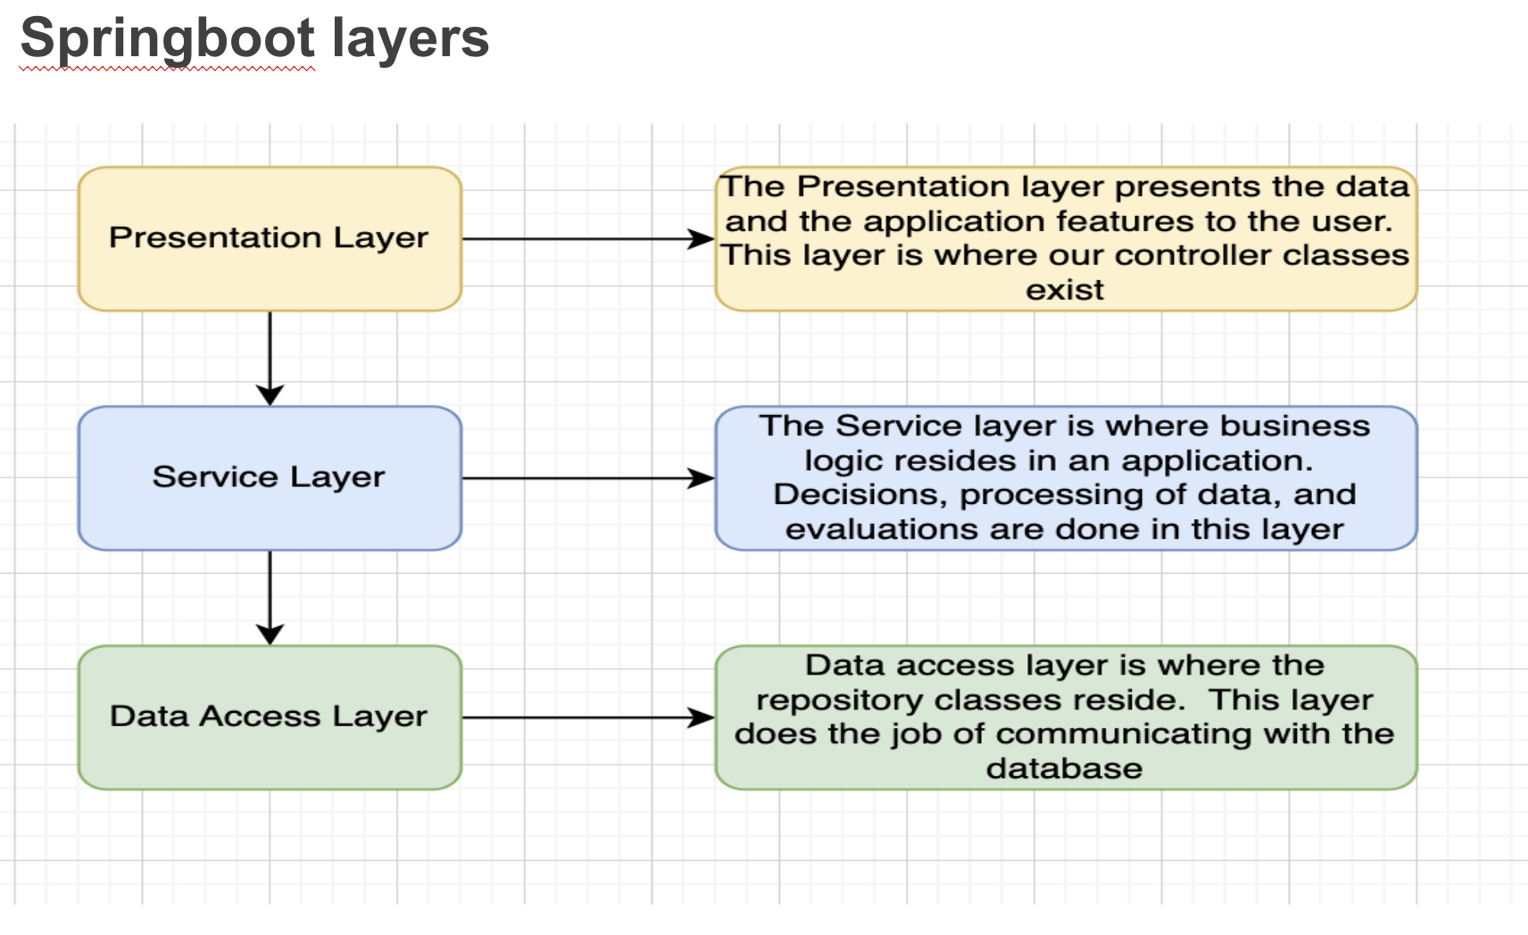

Creating a service

Most of the business logic happens in the service layer

The service layer accesses the repository and may transfer the information 1:1 or filter, transform, or alter the data first

Here is an example of the service layer for person:
import java.util.Optional;

import org.springframework.beans.factory.annotation.Autowired;
import org.springframework.stereotype.Service;

@Service
public class PersonService {

private PersonRepository personRepository;

@Autowired
public PersonService(PersonRepository personRepository) {
super();
this.personRepository = personRepository;
}

public Person findPersonById(long id) {
Optional<Person> p = personRepository.findById(id);
if(p.isPresent()) {
return p.get();
} else {
return null;
}
}

public Person savePerson(Person p) {
return personRepository.save(p);
}

// other CRUD methods omitted

}

Creating a REST controller

In the controller, we map the endpoints to methods

These methods call the service methods
Example
import org.springframework.beans.factory.annotation.Autowired;
import org.springframework.web.bind.annotation.GetMapping;
import org.springframework.web.bind.annotation.PathVariable;
import org.springframework.web.bind.annotation.PostMapping;
import org.springframework.web.bind.annotation.RequestBody;
import org.springframework.web.bind.annotation.RequestMapping;
import org.springframework.web.bind.annotation.RestController;

@RestController
@RequestMapping("api/person")
public class PersonController {

private PersonService personService;

@Autowired
public PersonController(PersonService personService) {
super();
this.personService = personService;
}

@GetMapping("{id}")
public Person getPersonById(@PathVariable long id) {
return personService.findPersonById(id);
}

@PostMapping
public Person addPerson(@RequestBody Person person) {
return personService.savePerson(person);
}

// other CRUD operations omitted

}

Calling the REST API

We can use the following endpoints to call our API:

http://localhost:8080/api/person/1 - GET

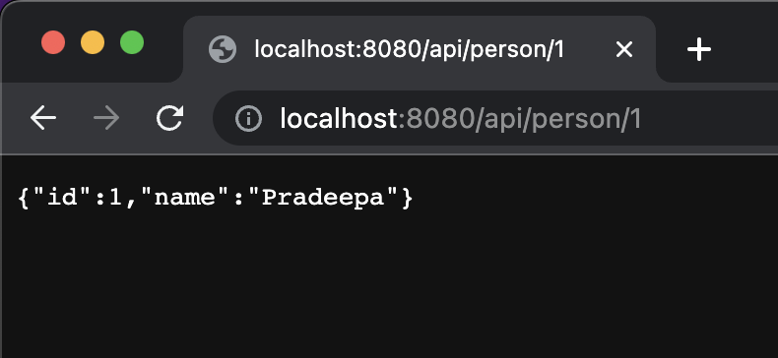

http://localhost:8080/api/person/ - POST

Add a body with the following format to your POST request
Example
{
"name" : "Nathan"
}

You’ll have to delete or comment out the import file to use the POST, otherwise, the generated value for id will run into problems trying to start with 1

Exercises
EXERCISE 1 (easy, optional)
- Copy and inspect the example from the previous pages in the example package

EXERCISE 2
- Create new project, HR app REST API
- Add a model for Employee, make this an entity and give it the following fields:
- Id
- Name
- Job
- Salary
- Date of birth
- Add the repository for your Employee objects
- Add a service that has methods for the following operations:
- Get all employees
- Get an employee by id
- Add a new employee
- Modify an employee
- Delete an employee
- Add a controller with the endpoints for the operations 4a – 4e.
- Test your application

Exercises cont’d
- BONUS: Can you update the project to use a MySQL database? (Hint: ask your new bestie Google)
- BONUS: Can you give your Employee an Address object? (Hint: google OneToOne Spring Boot and google for cascading if saving / deleting doesn’t go as you’d expect.)
- BONUS (very challenging!): What happens if you give your Employee a list of Projects and create a Project object for this? (Hint: google ManyToMany Spring Boot)

More complex data with Spring Boot Data JPA

Working with different relationships

OneToOne, when one object has another object, for example an Employee and a base location

OneToMany, when one object can have many of another object, for example customer and orders

ManyToOne, when many objects belong to one object, for example orders and a customer

ManyToMany, when many objects can belong to may objects, for example authors and books

More information on how to implement this with Spring Boot can be found here:

https://www.baeldung.com/jpa-one-to-one

https://www.baeldung.com/hibernate-one-to-many

https://www.baeldung.com/jpa-many-to-many

